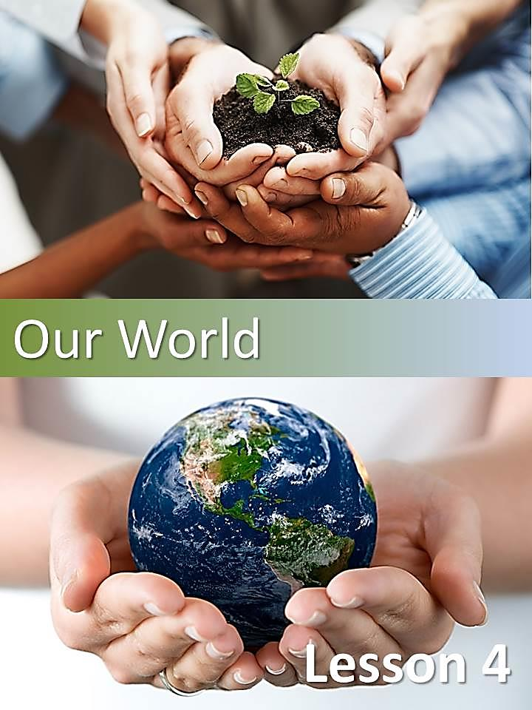

* 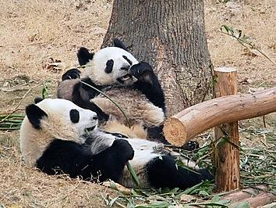Answer the following questions in Spanish.

1. What is the name of these white black bears?
2. What have you learnt about them?
3. Do you know they are in danger of extinction?

* What do you know about Giant Pandas? Read the following article and find out more about these cuddly black and white bears.

### Giant Pandas

**Introduction**

The giant panda has a distinctive white head with white eye patches, ears and shoulders. Unlike other bear species, giant pandas are spending up to 12 hours a day chewing bamboo shoots and roots. Despite being the subject of major international conservation efforts, wild populations of giant pandas may not be enough to save this species.

**Where does Pandas come from?**

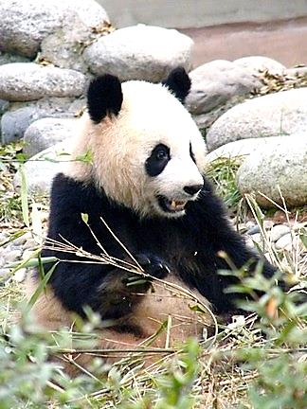Giant pandas have lived in the bamboo forests of China for millions years and have been honored by the Chinese for a very long time. In fact, giant pandas have appeared in Chinese art for thousands of years. Because the giant panda is considered a national treasure in China, it must be protected by law so that it doesn´t become extinct.

**At Panda’s Place: Where do pandas live?**

There is only one place where giant pandas can live in the wild: high in the mountains of central China. There, they live in cold and rainy bamboo forests. Once upon a time, giant pandas lived in lowland areas. However, as people built more and more farms and cities on that land, the giant pandas had to move into the mountains. Today, they live at elevations of 5,000 to 10,000 feet.

**Panda's Lunch: What do pandas eat?**

In the wild, a giant panda’s diet is 99% bamboo. Bamboo is a giant grass which grows in the mountains of China. Because bamboo is so low in nutrients, an adult giant panda must eat between 20 and 40 or more pounds of it each day. It eats the stems, shoots, leaves and all.

**There are about 25 different types of bamboo that wild pandas will eat.**

In zoos, giant pandas eat bamboo too, but they may also eat sugar cane, rice gruel, carrots, 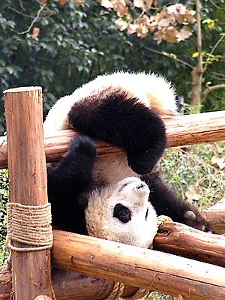apples and sweet potatoes.

Cubs nurse for about nine months but they should stay with their mothers for a long time after that. In fact, it should be up to three years before a giant panda cub strikes out on its own.

**Panda’s Day Out: How does a panda spend the day?**

Pandas are good climbers. They can also swim, though they spend most of their time on land. Although they might seem pretty quiet they make a lot of growling and honking sounds.

*  Prepare a Mind Map IN SPANISH using relevant information from the text using Key Words, remember to include information about:
  + Description
  + Place Of Origin
  + Where they live
  + What they eat
  + How they use their time

#### MC900404011[1]TENSES

* Find a verb in the following tenses. Why are these tenses used?

| **Tenses** | **Examples from the text**  **(In English)** | **Reason for their uses**  **(In Spanish)** |
| --- | --- | --- |
| Simple Past (irregular verb) |  |  |
| Simple Past (regular verb) |  |  |
| Present Continuous |  |  |
| Present Perfect |  |  |
| Future Simple |  |  |

#### MC900404011[1]MODAL VERBS

|  |  |
| --- | --- |
| *(Indicaremos el grado de probabilidad, certeza y contingencia en cubos)*  Imaginemos que estamos practicando alpinismo… | Picture |

##### Probabilidad

| **PRESENTE** | **PASADO** |
| --- | --- |
| Careful with this handle, it **MAY** break.  Picture  Careful with this handle, it **CAN** break.  Picture | Careful with this handle, it **MIGHT** break.  Picture  Careful with this handle, it **COULD** break.  Picture |

##### Certeza

|  |
| --- |
| **PRESENTE** |
| The HANDLE **WILL / HAS TO / MUST** break open. Picture  The HANDLE **SHOULD / OUGHT TO** break open. Picture  The HANDLE **NEEDS TO** break open. Picture |

**LOS VERBOS MODALES** que podemos usar para expresar **CERTEZA** funcionan del mismo modo para indicar **CONTINGENCIA – excepto WILL**.

##### Contingencia

|  |  |
| --- | --- |
| **PRESENTE** | **PASADO** |
| You **HAVE TO / MUST** take care of the handle.  Picture  You **SHOULD / OUGHT TO** take care of the handle.  Picture  You **NEED** to take care of the handle.  Picture  Where is the handle? It MAY HAVE broken off. Picture  Where is the handle? It CAN HAVE broken off. Picture | The handle **MIGHT HAVE** broken off.  Picture  The handle **COULD HAVE** broken off.  Picture |

* Read the following text and the function of the modal verbs.

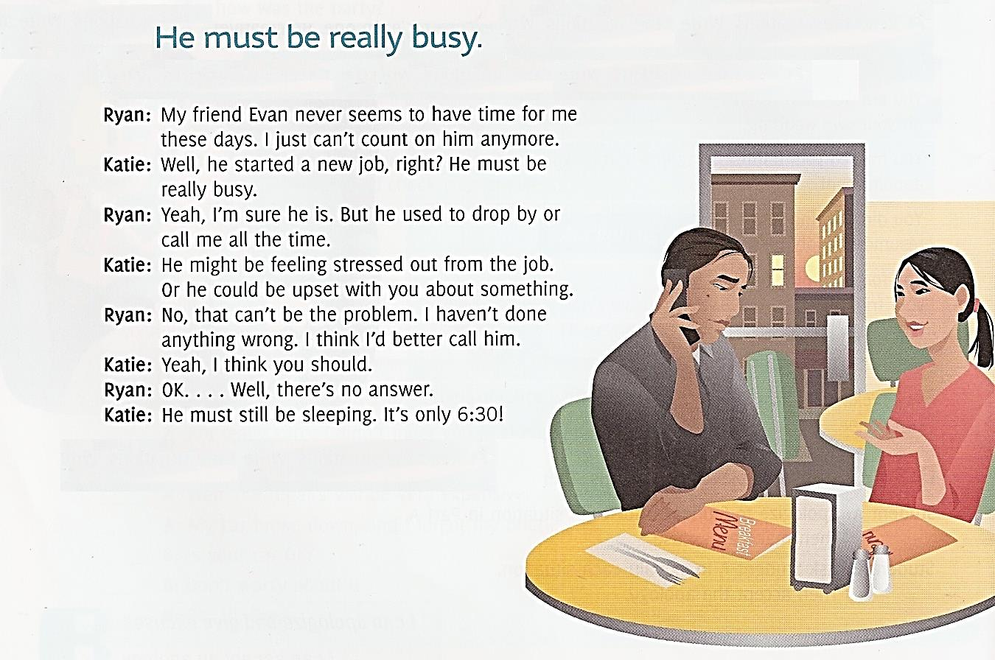

*  What does the text express about different uses of modal verbs?
* Find examples of sentences where modal verbs have been used and explain their function.

| **Examples from the text**  **(In English)** | **Use/Function**  **(In Spanish)** |
| --- | --- |
|  |  |
|  |  |
|  |  |
|  |  |
|  |  |
|  |  |
|  |  |

#### http://www.literautas.com/es/blog/wp-content/uploads/eye-magnifying-glass-book.gifRemember!

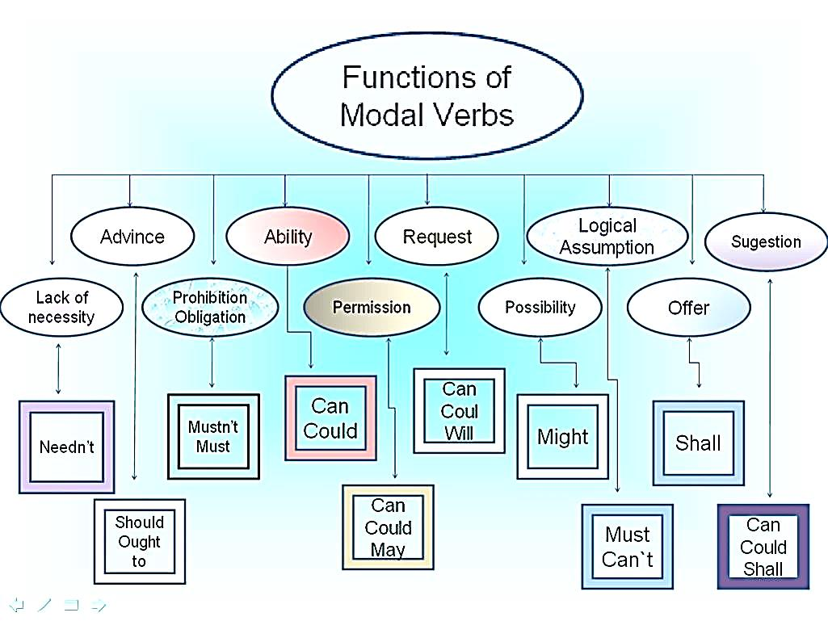

* Can you replace the modal verbs used in the text with others of similar meaning?

#### MC900404011[1]INCHOATIVE VERBS

Los *inchoative verbs* son verbos especiales que indican un “cambio de estado” cuando se les agrega un adjetivo a continuación.

|  |
| --- |
| **BECOME – GET – TURN – COME – GO**  **+ ADJECTIVE** |

* Become and get

**Become** and **get** pueden ser utilizados con la gran mayoría de los adjetivos para describir cambios de estado en personas y cosas. Ambos verbos son muy similares: “become” se utiliza más cuando se escribe y “get” cuando se habla.

|  |
| --- |
| **BECOME + ADJECTIVE**  **(ripe, old, cloudy, clear, etc.)**  **(** |

|  |  |  |  |
| --- | --- | --- | --- |
| ***E.g.*** | *The apples became ripe.*  *(The apples ripened.)* | Las manzanas se volvieron maduras.  (Las manzanas maduraron.) | **Ej.** |
| *He has become old.*  *(He has aged a lot.)* | Él se volvió viejo.  (Él envejeció.) |

|  |
| --- |
| **GET + ADJECTIVE**  **(angry, cold, upset, lost, trapped, hot, warm, etc.)** |

|  |  |  |  |
| --- | --- | --- | --- |
| ***E.g.*** | Eat your dinner before it gets cold. | Come tu comida antes de que se enfríe. | **Ej.** |
| *Be careful or you’ll get lost.* | Ten cuidado o te perderás. |

* Turn and go

Se puede utilizar el verbo **TURN**, o en un contexto más informal el verbo **GO**, se produce un cambio de color en las cosas o las personas.

|  |
| --- |
| **TURN / GO + ADJECTIVE** |

|  |  |  |  |
| --- | --- | --- | --- |
| ***E.g.*** | *Sam turned pale when he heard the news.* | Sam se puso blanco cuando escuchó la nocitia. | ***Ej.*** |
| Sam went pale when he heard the news. |

Se puede utilizar el verbo **GO** cuando se produce un cambio negativo en el cuerpo o en la mente de alguna persona.

|  |  |  |  |
| --- | --- | --- | --- |
| ***E.g.*** | Go crazy | Volverse loco | **Ej.** |
| Go blind | Volverse ciego |
| Go deaf | Volverse sordo |
| Go bald | Quedarse pelado |
| *Go bad* | Ponerse mal |

* Come

El verbo **COME** se utiliza en algunas expresiones con un significado positivo (de mejora): *come right, come true*, etc.

|  |
| --- |
| **COME + ADJECTIVE** |

|  |  |  |  |
| --- | --- | --- | --- |
| ***E.g.*** | All my dreams have come true. | Todos mis sueños se hicieron realidad. | **Ej.** |

* Now look at the text again. What kind of verb is BECOME?
* What is the writer’s intention when he states become + adjective?
* How can you express this in your mother tongue? “*When the poet became old...”*

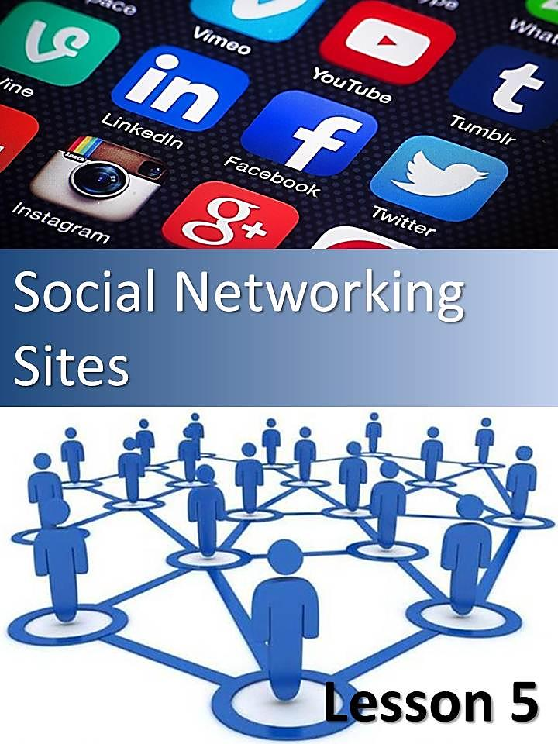

# Lesson 5

## Social Networking Sites

* Answer the following questions in Spanish.

1. How often do you use social networking sites?
2. Do you think there must be a limit as to the users’ age?
3. Do you share private issues?
4. Are children in potential danger because of their behavior on line?



* Reading activity.

### A Guide for Parents, Careers & Teachers

Social networking sites, such as MySpace, Bebo and Facebook, have largely increased their members. Some years ago, the users were only adults, but this situation has changed. Now, they are very popular with children, even those as young as 8 and 9. These sites have allowed children to be incredibly creative online, keep in touch with their friends and express using a whole range of different media and applications such as video, photos, music, and chat. However, it’s important to recognize that while these are fun and offer great possibilities for children, there are potential risks including cyber bullying, contact by adults with a sexual interest in children and the misuse of personal information. While most social networking sites have stipulated a minimum user age of 13 or 14 since the beginning, now users are often younger than this and as a parent, career or teacher it’s really important that you familiarize yourself with these services so that you can help to support your children in using them in a safe and constructive way. Social networking sites enabled users to put up their own pictures, text and videos (known as user-generated content) and blogging sites. They were part of a social and technological revolution, the Web 2.0. Its main characteristic is the ease with which anyone can produce and publish their own content and link with others. Young people especially love this new environment because they can have a powerful voice to express their identity and opinions. And all this is for free and with just one password – is it any wonder why young people love it?

**Private or public social life?**

What sometimes have appeared as a private space for a child can become public very quickly and this can potentially put a child at risk in two main ways:

* **Content:** Children who create or post inappropriate, offensive or even illegal content in their or others’ Web pages could get them into trouble with their school, friends, and even the police, depending on the nature of the material. Content posted to the Web can be copied, altered and reposted by anyone and it’s very difficult to ‘take back’ what may be later regretted.
* **Contact:** Children can also put too much personal information in these sites, exposing their information to adults with a sexual interest in children. Posting or chatting about personal details might enable someone to identify and contact your child online or in person. There is also the risk of cyber bullying with young people intentionally harming another person online. It is not easy talking to a young person about their social networking. Young people often think of these sites as their private domain. However because of the public nature of this environment and because young people have been hurt by inappropriate behavior in these spaces, it is important that they understand the risks and are able to safeguard themselves with the help and support of others.

Here are **5 P**s that should be considered about social networking sites.

1. **Positive:** Stay positive about social networking sites – try to reach a balance between educating children and young people to behave safely and trusting them to get on with it. Get involved – ask them how to create a profile, and ask them to add you to their friends list!
2. **Privacy:** Make sure that children know how to protect themselves on social networking sites through the tools provided. It’s important to discuss the value of privacy with children. Encourage your child to keep their passwords private and work with them to check the privacy settings on their account which limit how much of their information can be seen by others – for example, encourage your child to change their settings to private so that only people they allow can see what they post and comment on their space, rather than public which leaves their site open to be viewed by anyone.
3. **Photos:** It’s natural that children will want to include a photo on their site or profile, but help them think about the implications of posting photos and what is suitable. It is important to think about the type of picture and the kind of attention it can attract, the information it could divulge and who could see it. Suggest that your child ask permission of other people in the images that they post. Also, be aware that photos can be easily copied, changed, shared, used elsewhere, and can potentially stay online forever. One question to ask your child is “would they want a future employer to see this photo?”
4. **Postings:** The ability to interact with this media and comment on other people’s sites is part of what makes these sites so attractive. However, make sure you help your child to think before they post. Set some golden rules about what is and isn’t OK to say in a blog or profile. This relates to what the child says about others as much as about themselves. What started as a joke or gossip could escalate to cause real.
5. **Police:** It’s really important that you encourage your child to tell you about inappropriate or illegal activity they may come across. If you suspect your child was harassed by someone with a sexual interest in children, it’s vital that you help them keep a copy of the offending images or messages and report them to the police.

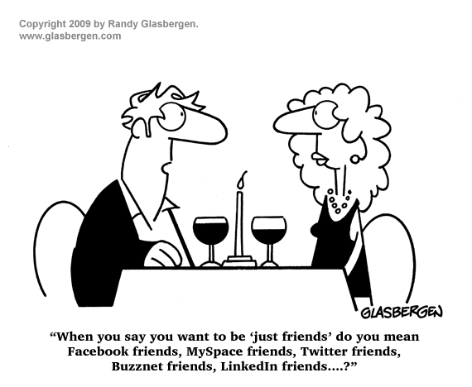

* Explain in Spanish the meaning of the five Ps.

|  |  |
| --- | --- |
| **Positive** |  |
| **Privacy** |  |
| **Photos** |  |
| **Posting** |  |
| **Police** | **Palabra clave**  Aquella palabra que resume la idea principal. |

* Complete the table with key words from the text.

|  |  |
| --- | --- |
|  |  |
|  |  |

* Complete the table with cognates from the text.

|  |  |  |
| --- | --- | --- |
|  |  |  |
|  |  |  |

**Palabra transparente o cognado**

Es el término que se utiliza para denominar a una palabra de una lengua X que guarda cierto parecido y comparte significado con una palabra de una lengua Y.

* Complete the following chart in Spanish.

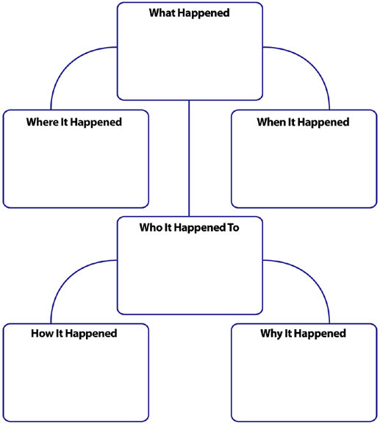

#### GRAMMAR IN USE

* Match the following as shown in the example.

|  |  |
| --- | --- |
| **Ing** as an adjective | stay positive about social networking sites |
| Imperative | offending |
| Modal verb | people’s sites |
| Possessive case | this can potentially put a child at risk |
| Noun | user |
| Comparative adjective | younger |

* Choose examples of the following tenses from the text and explain in Spanish why the author has used such tenses.

|  |  |  |
| --- | --- | --- |
|  | **Example from the text** | **Uses (in Spanish)** |
| **Simple present** |  |  |
| **Simple past** |  |  |
| **Present perfect simple** |  |  |

* In the following example, what does the word “since” mean? Point in time or period of time? Circle the correct answer.

|  |  |
| --- | --- |
| While most social networking sites have stipulated a minimum user age of 13 or 14 **since** the beginning… | POINT IN TIME  or  PERIOD OF TIME |

* Give the meaning of the following expressions from the text.

come across:

get on with:

#### PRESENT PERFECT SIMPLE

El tiempo verbal Present Perfect Simple se forma de la siguiente manera:

|  |  |  |  |  |
| --- | --- | --- | --- | --- |
| Sujeto | + | Verbo auxiliar  **HAVE** o **HAS** | + | Verbo principal  **participio pasado** |

|  |  |  |  |
| --- | --- | --- | --- |
| ***E.g.*** | *We have studied English since we were young.* | Hemos estudiado ingles desde que éramos jóvenes. | **Ej.** |
| *She has already played tennis.* | Ella ya ha jugado al tenis. |

Las formas afirmativa, negativa e interrogativa de este tiempo verbal se realizan de la siguiente manera:

|  | **English** | **Spanish** |
| --- | --- | --- |
| **Afirmativa** | We **have visited** that museum. | Hemos visitado ese museo. |
| **Negativa** | We **have not visited** that museum. |  |
| **Interrogativa** | **Have** we **visited** that museum? |  |

##### Contracciones

|  |  |
| --- | --- |
| I have | **I've** |
| You have | **You've** |
| He has | **He's** |
| She has | **She's** |
| It has | **It's** |
| We have | **We've** |
| They have | **They've** |

El tiempo Presente Perfecto Simple se utiliza en los siguientes casos.

* **Para transmitir experiencia**

presentperfect

A menudo, se emplea para expresar experiencias del pasado. No nos interesa cuándo se realizó la acción. Sólo queremos saber si se realizó.

|  |  |  |  |
| --- | --- | --- | --- |
| ***E.g.*** | *I've seen that film.* | He visto esa película.  (Tampoco importa el momento en que la vi.) | **Ej.** |

* **Para cambios o información nueva**

También utilizamos este tiempo para hablar sobre un cambio o información nueva.

|  |  |  |  |
| --- | --- | --- | --- |
| ***E.g.*** | *I have bought a car.* | He comprador un auto. | **Ej.** |
| *John has broken his leg.* | John se ha quebrado su pierna. |
| *Has the price gone up?* | ¿Ha aumentado el precio? |
| *The police have arrested the killer.* | La policía ha arrestado al asesino. |

* **Para acciones que comenzaron en el pasado pero todavía continúan**

presentperfectcontinuous

Empleamos este tiempo para referirnos a una situación que continua. Comenzó en el pasado y continúa en el presente y probablemente en el futuro. Por lo general, utilizamos **for** y **since** con esta estructura.

|  |  |  |
| --- | --- | --- |
| **Pasado** | **Presente** | **Futuro** |
|  |  |  |
| Las acciones comenzaron en el pasado. | Continúan hasta ahora. | Probablemente continuarán en el futuro. |

|  |  |  |  |
| --- | --- | --- | --- |
| ***E.g.*** | *He has lived in Canada for five years.* | Él comenzó a vivir en Canadá hace cinco años  (Y todavía sigue viviendo allí.) | **Ej.** |
| *We have worked at the University since 2010.* | Ella comenzó a trabajar en la Universidad desde el año 2010  (Y todavía continúa trabajando allí.) |

* **Para una acción no finalizada que uno está esperando**

Empleamos el presente perfecto para decir que una acción que esperábamos no ha tenido lugar. Se sugiere que todavía estamos esperando que suceda.

|  |  |  |  |
| --- | --- | --- | --- |
| ***E.g.*** | *James has not finished his homework yet.* | James no ha finalizado su tarea todavía. | **Ej.** |
| *Bill has still not arrived.* | Bill no ha llegado todavía. |
| *The rain hasn't stopped.* | No ha parado la lluvia. |
| *Susan hasn't mastered Japanese, but she can communicate.* | Susan no ha dominado al idioma japonés pero puede comunicarse. |

##### Usos de FOR y SINCE con el Presente Perfecto Simple

|  |  |  |  |
| --- | --- | --- | --- |
| Empleamos **for** para referirnos a un **período de tiempo:** 5 minutes, 2 weeks, 6 years, etc. | **FOR** | **SINCE** | Empleamos **since** para referirnos a un punto del pasado: 9 o'clock, 1st January, Monday, etc. |
| **a period of time** | **a point in past time** |
| |---------------| | ■→ |
| 10 minutes | 6.00 pm |
| Two days | Friday |
| nine months | February |
| 100 years | 1963 |
| centuries | 1810 |
| a long time | I got married |
| ever | the beginning of time |
| I have been here **for** 20 minutes… | … **since** 9 o'clock.  (It’s 9:20.) |

##### Active voice / Passive voice (See class 7.)

|  |  |  |
| --- | --- | --- |
| **ACTIVE** | http://www.conmishijos.com/pictures/posts/19000/19744-4-castillo-de-una-princesa-dibujo-para-colorear-e-imprimir.jpg | **PASSIVE** |
| Many tourists **have visited** that castle. | That castle **has been visited** by many tourists. |

#### http://www.literautas.com/es/blog/wp-content/uploads/eye-magnifying-glass-book.gifRemember!

Estas son las diferencias del pretérito perfecto simple con el pasado simple.

* **Énfasis en la acción o en el resultado**

|  |  |  |  |
| --- | --- | --- | --- |
|  | **Simple Past** | **Present Perfect Simple** |  |
| **Emphasis on action** | I bought a new bike yesterday. | I have bought a new bike so I can ride with you. | **Emphasis on result** |

* **Si el período de tiempo ha finalizado o no**

|  |  |  |  |
| --- | --- | --- | --- |
|  | **Simple Past** | **Present Perfect Simple** |  |
| **The time period has finished** | I painted my house last week. | I have painted my room this week. | **The time period has not finished** |

* **Si es información nueva o anterior**

|  |  |  |  |
| --- | --- | --- | --- |
|  | **Simple Past** | **Present Perfect Simple** |  |
| **You give older information** | He broke his leg last year. | He has broken her leg again. | **You give recent news** |

* **Si es un momento específico o no**

|  |  |  |  |
| --- | --- | --- | --- |
|  | **Simple Past** | **Present Perfect Simple** |  |
| **The time is clear** | I saw the movie last Friday. | I have seen that movie twice. | **The time is not specific** |

* **Si la acción ha finalizado o no (Uso de FOR and SINCE)**

|  |  |  |  |
| --- | --- | --- | --- |
|  | **Simple Past** | **Present Perfect Simple** |  |
| **For: the action is finished** | I lived there for two years. | I have lived there for ten years. | **For /since: the action isn’t finished** |

##### Referencias de tiempo

| **Simple Past** | **Present Perfect Simple** |
| --- | --- |
| yesterday | Just (recién) |
| last… | Already (ya) |
| …ago | Since (desde) |
| when she got married (past events) | Ever (alguna vez) |
| during the war… | so far (hasta ahora) |
| in 1980, on tuesday, etc. (past dates) | lately / recently (últimamente, recientemente) |

##### https://encrypted-tbn2.gstatic.com/images?q=tbn:ANd9GcQMUrr6GnOCwkz4PogUZJ2xQfw-qpxm2hYvF276ss5jXtHCDRfEPara finalizar…

Empleamos el Pasado simple para eventos o acciones pasadas SIN relación con el presente.

Empleamos el Presente perfecto para las acciones que comenzaron en el pasado y continúan en el presente, o para acciones finalizadas con relación con el presente.

No se puede emplear el Presente perfecto con una referencia de tiempo que implique tiempo finalizado.

En el Presente perfecto siempre hay una relación entre el presente y el pasado o viceversa, una idea pasada pero con resultados en el presente. El tiempo de la acción es anterior al ahora sin especificar y generalmente estamos más interesados en el resultado que en la acción en sí.

* Read the following table.

### Top 10 Most Popular Social Networking Sites and their Visitors | November 2014

|  |  |  |  |
| --- | --- | --- | --- |
| [Facebook](http://www.facebook.com/)  900,000,000 users | [Twitter](http://www.twitter.com/)  310,000,000 users | [LinkedIn](http://www.linkedin.com/)  255,000,000 users | [Pinterest](http://www.pinterest.com/)  250,000,000 users |
| [Google+](http://plus.google.com/)  120,000,000 users | [Tumblr](http://www.tumblr.com/)  110,000,000 users | [Instagram](http://www.instagram.com/)  100,000,000 users | [VKontakte](http://www.vk.com/)  80,000,000 users |
| [Flickr](http://www.flickr.com/)  65,000,000 users | | [Vine](http://www.vine.co/)  42,000,000 users | |

* Answer the questions in Spanish.

1. Which is the largest European social network with nearly 80 million active users?
2. How many tweets have you published this week?
3. Have you read Facebook posts yet?
4. Have you posted any pictures in Flickr?
5. When did you open your Facebook account?
6. Have you used Instagram to share your photos?
7. Have you included your UNLa education in Linkedin?
8. When did you start using these sites?

* Complete the chart.

| **Name two finished actions** |
| --- |
|  |
|  |
| **Name two non-finished actions** |
|  |
|  |

